**LEBANESE AMERICAN UNIVERSITY**

**USAID – HIGHER EDUCATION SCHOLARSHIP PROGRAM**

**HES - Volunteering Program Verification Form**

This form is to be used to document volunteering hours. If a student volunteers for multiple organizations, a separate form must be used for each organization. **This form must be turned in by the 28th of each month, the latest.**

I certify that the scholar sara kalakesh completed a total of 5 hours of service at InnovaThrive.

The hours were completed hours as per the below:

Hours # 0 (date) _2/12 – 6/12_ (initials of supervisor) __A.K.___

Hours # 0 (date) _9/12 – 13/12_ (initials of supervisor) __A.K.___

Hours # 0 date) _16/12 – 20/12 (initials of supervisor) __A.K.___

Hours # 5 date) _23/12 - 27/12 (initials of supervisor) __A.K.___

Brief description of the activities the scholar performed or participated in:

I was assigned to explore the use of blockchain technology in enhancing digital copyright protection. My task focused on how decentralized ledger systems can effectively track ownership and licensing rights, thereby providing secure digital ownership for creators and consumers. I also examined the role of smart contracts in automating copyright enforcement and discussed the advantages of using blockchain for digital copyrights as well as its disadvantages. I was also required to identify future research opportunities, including the integration of blockchain with AI for enhanced content protection and the potential for expanding blockchain applications in digital rights management across emerging media formats.

Written feedback about the scholar’s performance:

Sara demonstrates strong analytical and research skills, effectively exploring the use of blockchain for digital copyright protection. Her ability to connect blockchain with AI for future advancements showcases her forward-thinking and technical expertise.

Please rate the overall performance of the scholar at your organization:

|  |  |  |  |
| --- | --- | --- | --- |
|  | Mastery (5) | Proficient (3) | Emerging (1) |
| **Problem solver** | X |  |  |
| **Engaged & Committed** | X |  |  |
| **Open-minded & multicultural** | X |  |  |

Signature

& stamp

__________________________

_

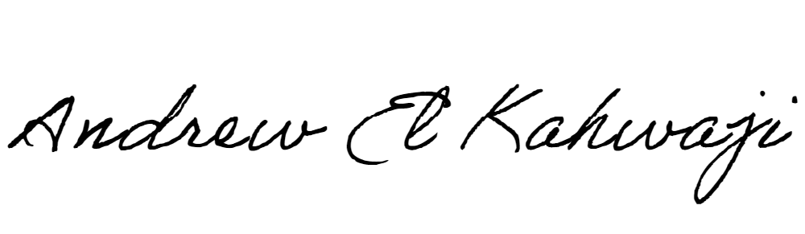

Printed Name _Andrew El Kahwaji_

Date __26/12/2024___

Email __andrew.lifesculptor.coo@gmail.com __

Phone __+961 71 914 378__